|  |  |  |  |
| --- | --- | --- | --- |
| 2 | | 40,032.0 | |
| NUMERO DE FRONTERAS | | ENERGIA AGREGADA | |
|  | | | |
| SI | | 13-03-2021 | |
| CONTRATO | | VENCIMIENTO CONTRATO | |
|  | | | |
| 134,244,866 | 143 | | 6,102,124 |
| INGRESO 2021 | DÍAS CERTIFICADOS 2021 | | ENERGIA RESPALDADA 2021 |

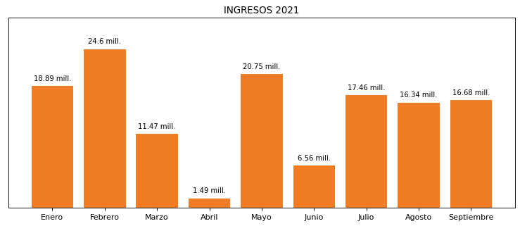

|  |
| --- |
| **PUERTO BUENAVENTURA**  USUARIO |

|  |
| --- |
| **Camilo Bermudez**  Ejecutivo de cuenta |

|  |
| --- |
| **0**  Primera fecha: PUNTO FOCAL |

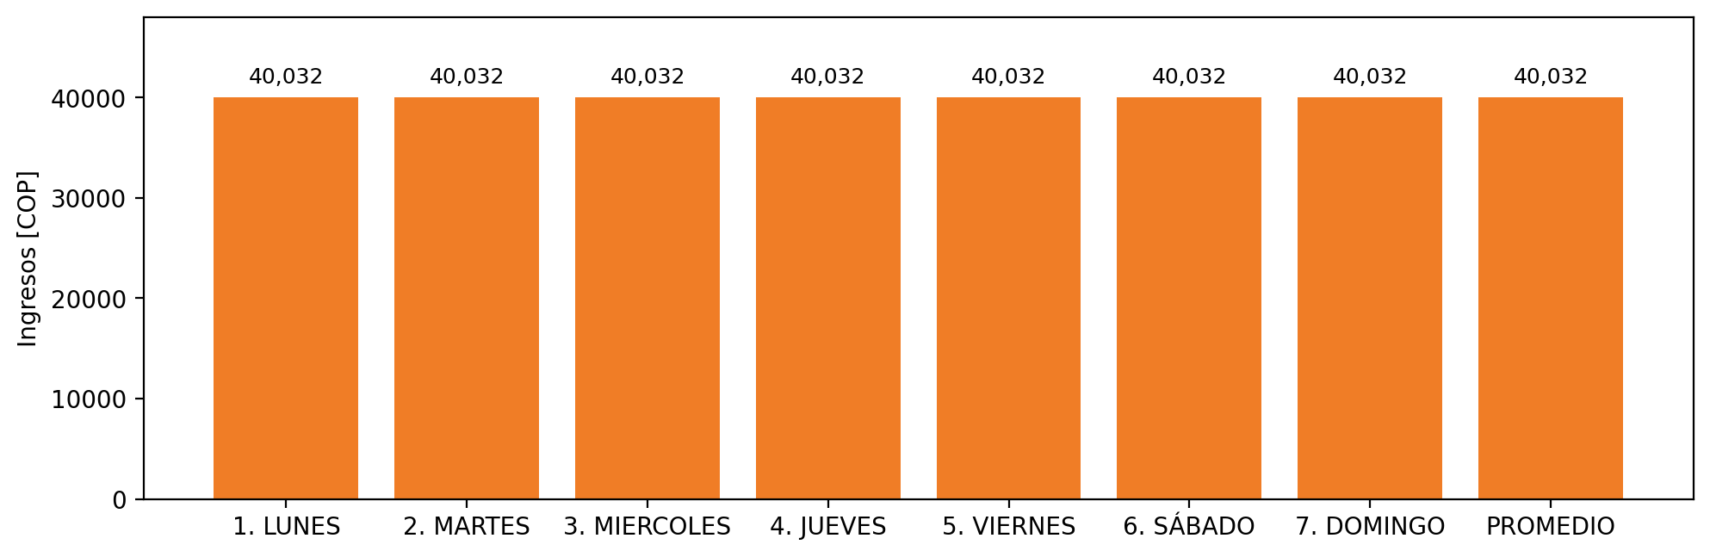

|  |  |  |  |  |  |  |  |  |  |
| --- | --- | --- | --- | --- | --- | --- | --- | --- | --- |
| **FRONTERA COMERCIAL** | **TIPO DDV** | **COD SIC** | **PREDIO** | **PROMEDIO** | **MARGEN** | **ÚLTIMA DESCONEXION** | **DÍAS CERTIFICADOS** | **ACTUALIZACION** | **PROXIMA PRUEBA DDV** |
| SOCIEDAD PORTUARIA REGIONAL DE BUENAVENTURA S.A. | Frt39459 | Frt00597 | Prd02130 | 20,016 | NO APLICA | 2021-06-30 | 75.0 | 2026-04-15 | 2021-11-30 |
| SOCIEDAD PORTUARIA REGIONAL DE BUENAVENTURA S.A. | Frt39793 | Frt24402 | Prd02035 | 20,016 | NO APLICA | 2021-06-30 | 35.0 | 2026-04-15 | 2021-12-01 |